

**DK32**

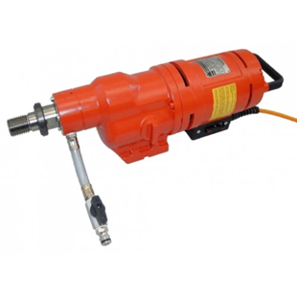

|  |  |
| --- | --- |
| Spanning (V) | 230 |
| Gewicht (Kg) | 11.9 |
| Toerental | 300/590/930 |
| Max. boordiameter (mm) | 350 |
| Vermogen (W) | 3200 |
| Opname | 1.25 |
| Lengte (mm) | 488 |
| Toepassing | Steen, Beton |