

**C18037**

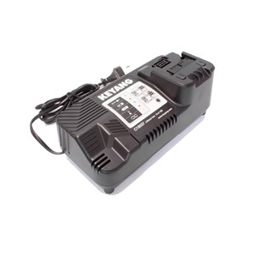

**Kenmerken C18037 - Snellader 14.4-18V**

- Voltage - 14.4-18V  
- Type - Li-Ion.