

**BL18012**

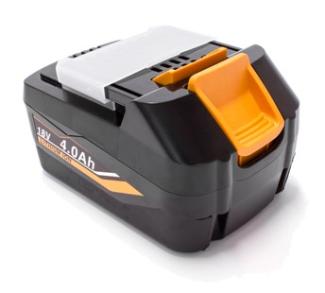

**Kenmerken BL18012 - Accu 18V 4.0Ah**

- Voltage - 18V  
- Amperage - 4.0Ah  
- Type - Li-Ion.