

**BL14406**

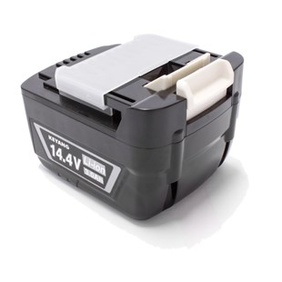

**Kenmerken BL14406 - Accu 14.4V 3.0Ah**

- Voltage - 14.4V  
- Amperage - 3.0Ah  
- Type - Li-Ion.