

**BL10802**

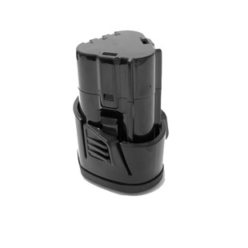

**Kenmerken BL10802 - Accu 10.8V 1.5Ah**

- Voltage - 10.8V  
- Amperage - 1.5Ah  
- Type - Li-Ion.