

**TCT P165**

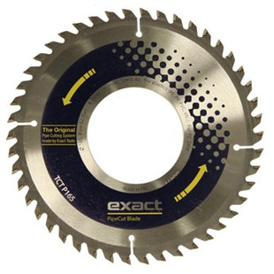

|  |  |
| --- | --- |
| Type | TCT P165 |
| Afmetingen | 165 x 62 x 1.8 x 1.4 x 40 |
| Materiaal | Kunststof (PE, PP, PVC, etc.) |
| Zaagmachine | 280E |