

**TCT 140**

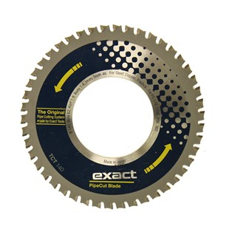

|  |  |
| --- | --- |
| Type | TCT 140 |
| Afmetingen | 140 x 62 x 1.8 x 1.4 x 46 |
| Materiaal | Staal, koper, kunststof |
| Zaagmachine | 170, 170E, 200, 360 |