

**Lang**

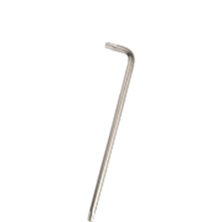

**Torx-sleutels, lang**

Uitvoering

Torx sleutel lang model, vernikkelde uitvoering.

|  |  |  |  |  |
| --- | --- | --- | --- | --- |
| Art.nr. |  | Grootte | Lengte | Uitvoering |
| 890.2005 |  | T5 | 84 | Vernikkeld |
| 890.2006 |  | T6 | 84 | Vernikkeld |
| 890.2007 |  | T7 | 96 | Vernikkeld |
| 890.2008 |  | T8 | 96 | Vernikkeld |
| 890.2009 |  | T9 | 96 | Vernikkeld |
| 890.2010 |  | T10 | 100 | Vernikkeld |
| 890.2015 |  | T15 | 108 | Vernikkeld |
| 890.2020 |  | T20 | 114 | Vernikkeld |
| 890.2025 |  | T25 | 126 | Vernikkeld |
| 890.2027 |  | T27 | 134 | Vernikkeld |
| 890.2030 |  | T30 | 140 | Vernikkeld |
| 890.2040 |  | T40 | 152 | Vernikkeld |
| 890.2045 |  | T45 | 170 | Vernikkeld |
| 890.2050 |  | T50 | 190 | Vernikkeld |
| 890.2055 |  | T55 | 216 | Vernikkeld |
| 890.2060 |  | T60 | 240 | Vernikkeld |