

**Metrisch, kort**

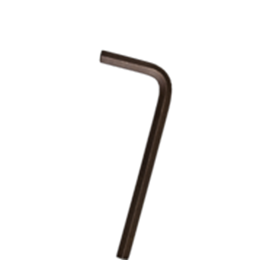

**Inbus-sleutels, metrisch, kort**

Uitvoering

Zeskant inbussleutel, metrisch, kort model. DIN ISO 2936L (DIN 911L)

|  |  |  |  |  |
| --- | --- | --- | --- | --- |
| Art.nr. |  | Grootte | Lengte | Uitvoering |
| 878.0015 |  | 1,5 | 44 | Zwart |
| 878.0025 |  | 2,5 | 55 | Zwart |
| 878.0030 |  | 3,0 | 63 | Zwart |
| 878.0040 |  | 4,0 | 70 | Zwart |
| 878.0050 |  | 5,0 | 80 | Zwart |
| 878.0060 |  | 6,0 | 90 | Zwart |
| 878.0070 |  | 7,0 | 95 | Zwart |
| 878.0080 |  | 8,0 | 100 | Zwart |
| 878.0090 |  | 9,0 | 105 | Zwart |
| 878.0100 |  | 10,0 | 112 | Zwart |
| 878.0110 |  | 11,0 | 118 | Zwart |
| 878.0120 |  | 12,0 | 125 | Zwart |
| 878.0140 |  | 14,0 | 140 | Zwart |
| 878.0170 |  | 17,0 | 160 | Zwart |
| 878.0190 |  | 19,0 | 180 | Zwart |
| 878.0220 |  | 22,0 | 200 | Zwart |
| 878.0240 |  | 24,0 | 224 | Zwart |
| 878.0270 |  | 27,0 | 255 | Zwart |
| 878.0320 |  | 32,0 | 315 | Zwart |
| 878.0360 |  | 36,0 | 355 | Zwart |