

**Inch-maten, set**

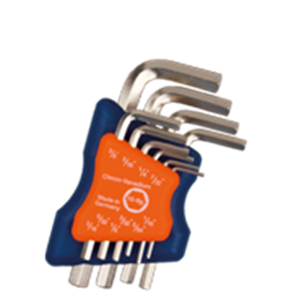

**Inbus-sleutelset, inch-maten, kort**

Uitvoering

Handige set vernikkelde inbussleutels in compacte houder, kort model, metrisch. DIN ISO 2936L (DIN 911L)

|  |  |  |  |
| --- | --- | --- | --- |
| Art.nr. |  | Omschrijving | Inhoud |
| 878.9006 |  | 10-dlg. Set inbussleutels | 1x 1/16", 5/64", 3/32", 1/8", 5/32", 3/16", 7/32", 1/4", 5/16" en 3/8" |