

**Quick-change starter-kits (HM)**

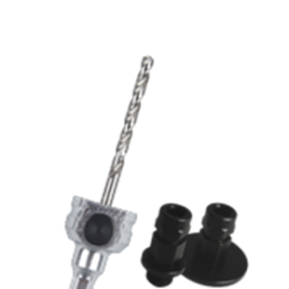

**Quick-Change Starterkits (HM)**

Uitvoering

Quick Change houder met 1 adapter 1/2x20 UNF en 1 adapter  
5/8x18 UNF t.b.v. MP gatzagen, inclusief adapters.

|  |  |  |  |  |
| --- | --- | --- | --- | --- |
| Art.nr. |  | Omschrijving | Schacht | Centreerb. |
| 528.3121 |  | QC Starter-kit (HM) | 6-knt. 8,5 | HM |
| 528.3106 |  | QC Starter-kit (HM) | 6-knt. 11 | HM |