

**Quick-change starter-kits**

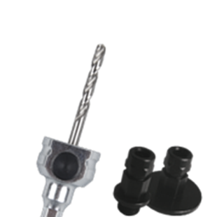

**Quick-Change Starter-Kits**

Uitvoering

Quick Change houder met 1 adapter 1/2x20 UNF en 1 adapter  
5/8x18 UNF t.b.v. HSS-Bi gatzagen.

|  |  |  |  |  |
| --- | --- | --- | --- | --- |
| Art.nr. |  | Omschrijving | Schacht | Centreerb. |
| 527.3106 |  | QC Starter-Kit | 6-knt. 8,5 | HSS |
| 527.3111 |  | QC Starter-Kit | 6-knt. 11 | HSS |