

**Tiger Basic**

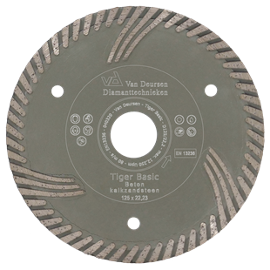

|  |  |
| --- | --- |
| Toepassing | Beton, kalkzandsteen |
| Diameters Ø | 125-150 |
| Asgat | 22,23 |
| Segmenthoogte | 9 mm |
| Gebruik | Droog |

Per 10 stuks te bestellen.

|  |  |
| --- | --- |
| N6430104 | # 5910241 - Dia-TS / 125/22,23 / Tiger Basic / gesintert / Universal 2,2 x 9 mm / Turbo / Schutzsegmente / Steingrau / verpackt a 10 stuck |

|  |  |
| --- | --- |
| N6430105 | # 5910243 - Dia-TS / 150/22,23 / Tiger Basic / gesintert / Universal 2,2 x 9 mm / Turbo / Schutzsegmente / Steingrau / verpackt a 10 stuck |