Performer Matrix
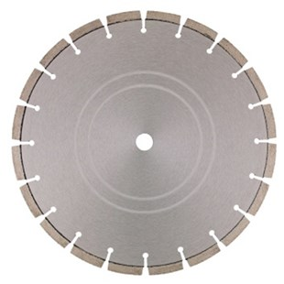
Toepassing | Graniet, harde beton, kalkzandsteen
Diameters Ø | 300-350-400
Asgat | 20-22,23-25,4-30
Segmenthoogte | 10 mm
Gebruik | Droog en nat

N7806912 | 6700135 - Dia-TS Ø300 x 20 mm / Performer Matrix 40 x 2,8 x 10 mm
N7806915 | 6700137 - Dia-TS Ø300 x 25,4 mm / Performer Matrix 40 x 2,8 x 10 mm
N7806920 | 6700139 - Dia-TS Ø350 x 20 mm / Performer Matrix 40 x 3,2 x 10 mm
N7806925 | 6700141 - Dia-TS Ø350 x 25,4 mm / Performer Matrix 40 x 3,2 x 10 mm
N7806930 | 6700143 - Dia-TS Ø400 x 20 mm / Performer Matrix 40 x 3,2 x 10 mm

