

**Dunwandig R1/2 Wave**

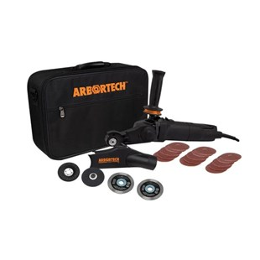

**Type Wave gesoldeerd**

Voor het boren in diverse bouwmaterialen, zoals: beton en baksteen.  
Uitsluitend nat te gebruiken.

|  |  |
| --- | --- |
| Aansluiting | R1/2 |
| Diameters | 210 t/m 350 |
| Lengte | 300 mm |
| Segmenthoogte | 12 mm |

|  |  |
| --- | --- |
| 51003102103000 | 210/300 R1/2 Diamantboor dunwandig WAVE |
| 51003102203000 | 220/300 R1/2 Diamantboor dunwandig WAVE |
| 51003102300030 | 230/300 R1/2 Diamantboor dunwandig WAVE |
| 51003102400030 | 240/300 R1/2 Diamantboor dunwandig WAVE |
| 51003102500300 | 250/300 R1/2 Diamantboor dunwandig WAVE |
| 51003102600300 | 260/300 R1/2 Diamantboor dunwandig WAVE |
| 51003102700300 | 270/300 R1/2 Diamantboor dunwandig WAVE |
| 51003102800300 | 280/300 R1/2 Diamantboor dunwandig WAVE |
| 51003102900300 | 290/300 R1/2 Diamantboor dunwandig WAVE |
| 51003103000300 | 300/300 R1/2 Diamantboor dunwandig WAVE |
| 51003103100300 | 310/300 R1/2 Diamantboor dunwandig WAVE |
| 51003103200300 | 320/300 R1/2 Diamantboor dunwandig WAVE |
| 51003103300300 | 330/300 R1/2 Diamantboor dunwandig WAVE |
| 51003103503000 | 350/300 R1/2 Diamantboor dunwandig WAVE |