

**Dunwandig R1/2 ring Fury**

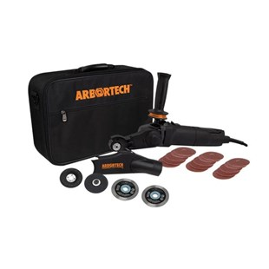

**Type Fury**

Voor het boren in diverse bouwmaterialen, zoals: beton en baksteen.  
Uitsluitend nat te gebruiken.  
Gepositioneerde diamant in segmenten.

|  |  |
| --- | --- |
| Aansluiting | R1/2 |
| Diameters | 10 t/m 16 |
| Lengte | 300/600/1000/1500 mm |
| Segmenthoogte | 10 mm |

|  |  |
| --- | --- |
| Artikelcode | Omschrijving |
| 51000800100150 | 010/150 R1/2 Diamantboor dunwandig Fury |
| 51000800100300 | 010/300 R1/2 Diamantboor dunwandig Fury |
| 51000800100600 | 010/600 R1/2 Diamantboor dunwandig Fury |
| 51000800101000 | 010/1000 R1/2 Diamantboor dunwandig Fury |
| 51000800101500 | 010/1500 R1/2 Diamantboor dunwandig Fury |
| 51000800120150 | 012/150 R1/2 Diamantboor dunwandig Fury |
| 51000800120300 | 012/300 R1/2 Diamantboor dunwandig Fury |
| 51000800120600 | 012/600 R1/2 Diamantboor dunwandig Fury |
| 51000800121000 | 012/1000 R1/2 Diamantboor dunwandig Fury |
| 51000800121500 | 012/1500 R1/2 Diamantboor dunwandig Fury |
| 51000800140300 | 014/300 R1/2 Diamantboor dunwandig Fury |
| 51000800140600 | 014/600 R1/2 Diamantboor dunwandig Fury |
| 51000800141000 | 014/1000 R1/2 Diamantboor dunwandig Fury |
| 51000800141500 | 014/1500 R1/2 Diamantboor dunwandig Fury |
| 51000800150300 | 015/300 R1/2 Diamantboor dunwandig Fury |
| 51000800150600 | 015/600 R1/2 Diamantboor dunwandig Fury |
| 51000800151000 | 015/1000 R1/2 Diamantboor dunwandig Fury |
| 51000800151500 | 015/1500 R1/2 Diamantboor dunwandig Fury |
| 51000800160300 | 016/300 R1/2 Diamantboor dunwandig Fury |